**PRACTICAL GEOGRAPHY**

**(Master key to Mapwork, Photograph Interpretation and Fieldwork)**

**Appropriate for “O” Level and “A” level with objective questions**

**ISOOBA IVAN (B.A.EDUC, MUK)**

**First Edition 2020**

**Revised Edition 2021**

**PREFACE**

This book provides knowledge about Mapwork, photograph interpretation, and guidelines on how to plan, conduct and conclude fieldwork study.

The various aspects under study have been integrated with demonstration exercises geared towards simplifying the teaching and learning process of geography at secondary school level.

**DEDICATION**

This book is dedicated to my mother Nakitto Safina.

Your contribution to my education cannot be underestimated.

**ACKNOWLEDGMENT**

Mr. Wabwire Fred (Geography Teacher)

Mr. Ndego Hakim (Geography Teacher Mengo SS)

Mr. Nganda Francis (Geography Tr Young Christian SS)

Mr. Musoke Francis (Geography Teacher)

Mr.Kiwanuka Henry (Geography Tr Bethel High sch.)

Namuyingo Irene (Typist)

Mukiibi Mark Mpande (Editor)

*All rights reserved at [isoobaivan19@gmail.com](mailto:isoobaivan19@gmail.com)*

**TABLE OF CONTENTS**

MAPWORK 1

Grid references 1

Directions 2

Bearings 2

Calculating/Measuring Area on a Map 3

Measuring curved distance 4

Finding the shortest distance between two points/places. 4

Relief on the maps 4

Contour Interval/Vertical Interval 9

Determining intervisibility 9

Drawing a sketch map 10

Reduction of a Sketch map. Steps to Map reduction. 10

Enlargement of a sketch map. 11

Drawing a cross/relief section. 13

Draw a cross section of the area between points A and B and on it mark and Label: 14

Calculating Vertical Exaggeration. 15

Calculating the Gradient. 15

Calculating of De-tour index 17

Measurement of the trend of irregular objects on the Map extract. 17

Interpretation of Human activities on a Map extract 18

Settlement Patterns. 19

Drainage patterns 21

Problems facing the people in a given area on the Map. 23

Geographical Relationships 23

Sample Questions on Map work 26

PHOTOGRAPH INTERPRETATION 31

Types of Photographs 31

Characteristics of Ground photographs 32

Characteristics of Aerial photographs 33

Satellite Photographs 33

Illustration of a Satellite photograph 34

Interpretation of Photographs 34

Tone of the photograph 35

Identification of features on aerial photographs 35

Drawing a Landscape sketch from the Photograph 35

Worked Examples 35

Do it yourself (Exercise) 44

FIELDWORK 48

Reasons for carrying out Fieldwork studies 48

Procedure/Stages of carrying out fieldwork 48

Pre-field study or Pre-field preparation or Preparation stage. 49

Examples of topics 49

Real/Actual Fieldwork 50

Illustration on how to present methods of data collection. 51

SKETCH MAPS 58

TRANSECT. 59

PANORAMA 59

COMMON MISTAKES WHILE PRESENTING DATA COLLECTION METHODS 60

Limitations of the methods of Data collection (Problems / Challenges faced during Fieldwork study) 61

Skills Gained from the Fieldwork study. 62

STUDY FINDINGS (Findings of the fieldwork study) 62

The Impact/Effect/Influence of the activity on the Environment 65

Recommendations of the fieldwork study 66

Future prospects 66

Problems facing the area of study 67

FIELDWORK ON FISHING LANDING SITES 67

KASENYI FISH LANDING SITE 67

FIELDWORK ON A FARM (LARGE OR SMALL) 74

Sample Questions 76

OBJECTIVE QUESTIONS 83

Geography Adjectives (Qualifiers & Quantifiers) Physical 96

**MAPWORK**

**Grid references**

Grid references refer to horizontal and vertical lines forming a network of squares on a map.

**Location of features on topographical maps.**

We use grid references to locate features on topographical maps.

Grid references are made up of **horizontal** and **vertical** lines called **Northings** and **Eastings** respectively.

**Eastings**

These are the vertical lines. They are called so because they are numbered in an increasing order towards the Eastern direction.

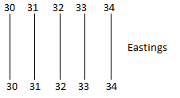

**Northings**

These are the horizontal lines.

They are called so because they are numbered Northwards.

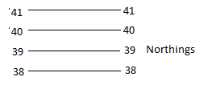

Grid references are given six figures. Only large numbers are used on the Map extract.

**Note;**

The formular used in Grid reference readings is **EN** where **E** stands for **Eastings** and **N** for **Northings.**

The figures for Easting line should be read first then the Northing last.

The Easting line chosen should be the one on the left of the reader.

The Northing line chosen should be the one below the feature not above.

**Example:**

Using the section of the map below the six grid references for the points X, Y and Z are;

X - 625445

Y - 681495

Z – 709466

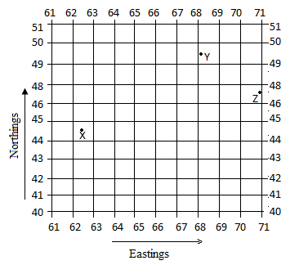

**Directions**

The directions are based on the cardinal points and other minor points.

**Compass Direction**

**Example**

Find the direction of X from Y.

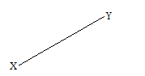

Find the direction of Y from X.

**Solution**

1. The first question asks that when one is standing at Y, where is X?

X is in the South west of Y.

2. For question 2 asks that when one is standing at X, where is Y?

Y is in the North East.

**Bearings**

We measure direction on the map extracts using a system of degrees called bearing. In the system, the **North** becomes **0°**,**East 90°**, **South 180°** and **West 270°**

**Steps to finding the bearing**

i) Identify the two points/places required.

ii) Draw a line joining the two points/places using a pencil.

iii) Draw a compass point at the point from which the bearing is required.

iv) Place a protractor and then measure the degrees from the clockwise direction.

**Example**



i) Find the bearing of X from Y.

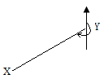

**Solution**

Bearing =. 90 + 90 + 45 = 225°

**Note:**

Bearings are given using 3 figures.

**Calculating/Measuring Area on a Map**

When measuring area with irregular shapes such as lakes, swamps, forests, plantations, etc, grid squares are counted.

Area of each grid square is equivalent to **1km²**

**Procedure for calculating/ measuring Area on map.**

i) Count the number of full squares covered by the feature.

ii) Count the number of half squares covered by the feature and divide by 2.

iii) The formular is **A=M+**

Where; **M =** Number of full squares.

**n =** Number of half squares.

**Therefore** Area =. Number of full squares **+** 

**Example:**

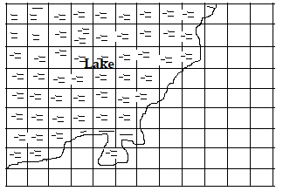

Calculate the area covered by the lake in the diagram above

**Solution**

Area = Number of full squares + 

Number of full squares = 45

Number of half squares = 19

Area = 45 **+**

= 45 + 9.5 = 54.5 squares

But Area of one square = 1 × 1 = **1km²**

Therefore Area = 54.5 × **1 km²**

= 54.5 **km²**

**Measuring curved distance**

The features may be road, railway, river, etc. The methods used are;

**i) Using a paper edge.**

The paper is placed along the feature following its patterns.

A pencil is used to note the changing patterns along the paper.

Place the paper along the linear scale on the map extract to establish the distance in kilometers.

**Illustration**

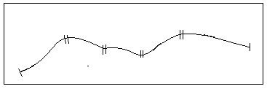

**ii)Using a string/thread**

Lay a length of thin string which does not stretch along the curved distance.

It may be a road, river, etc.

The thread/string should follow the curves and then stretch it along the linear scale to obtain the distance.

**Finding the shortest distance between two points/places.**

This is done by drawing a straight line between the two points/places, then a paper or thread is placed on the line and then on the linear scale to establish the distance

**Example**

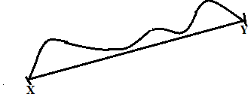

**Relief on the maps**

**Relief** refers to the appearance of the landscape.

It consists of mountains, valleys, hills, relatively flat landscape, dissected plateau, low lands, etc.

**Methods of representing Relief on maps (Topographical maps) Contours and Form lines**

**Contours** are also called **Isohyets**.

Contours are lines drawn on maps to join all points/areas/places with the same height above sea level.

Contours are tiny brown lines drawn on topographical maps to show the height of regions.

**Form lines** on the other hand are similar to Contours in that they are faint but usually not numbered.

**Note:** The Contours are dark and numbered.

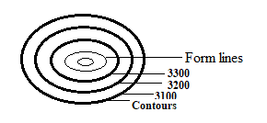

The appearance or arrangement of contours determines the nature of landscape/relief/landforms of an area as illustrated below;

Highland/Hill/Inselberg/Conical hills.

This is represented by contours which form an oval or circular shape.

Steep slopes/steep hill/highland.

This is shown by contours which are near each other.

Gentle slopes.

This is shown by the contours which are spaced.

**Illustration of Highlands/Hills/Conical hills, Steep slopes/ Steep hill, and** **Gentle slopes.**

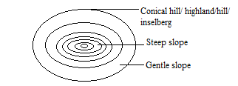

**iv) Flat topped hills** they have a flat top and steep slopes. It is illustrated as below.

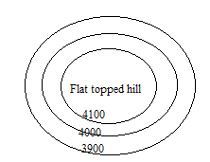

**v) Plateau**

This is a raised area of flat land. It is illustrated as follow;

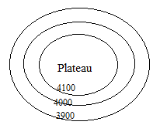

**vi) Dissected plateau**

This is where the rivers cut deep in the plateau. It is illustrated as below;

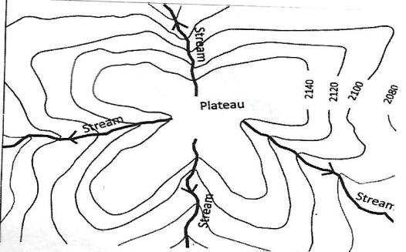

**vii) Flatland**

It is shown by contours which are widely spaced with a small vertical interval.

**OR** It is shown by uniformly numbered consecutive contour lines. E.g. where each is numbered 2200, then 2200,2200.

**viii) Lowland/Low landscape**

It is shown by contours which do not form a circular pattern but are generally spaced. **OR** It is also shown by the presence of swamps, seasonal swamps, tree swamps, mangrove swamps and palms.

**ix) Basins**

Basins are occupied by lakes.

**x) Bay**

This is a large body of water projecting into the adjacent land.

A very large Bay is called a Gulf e.g Gulf of Mexico, Gulf of California, etc.

**xi) Headland**

An headland is a piece of land that projects into the adjacent water body.

**Illustration of Bays and Headlands.**